June 18, 2024
VR Brain Gameplay Mechanics Development
Step 1: Defining Click Region Coordinates for 3 Brain Structures

The brain structures that have been selected for this initial stage of development are part of the “Easy” gameplay setting. This means that they are less fine-grained (i.e., the thalamus rather than subnuclei of the thalamus). The selected structures are the corpus callosum (blue spheres), the thalamus (blue squares), and the left occipital cortex (blue cylinders). The scene associated with this work is “scene49_threeStructure_coordinates.mb.”
Shapes for internal structures of the brain have been placed in intermediate positions between slices, so that they define locations on both adjacent slices. Shapes for external surfaces of the brain have been placed throughout the region, but only the surface of the brain should be clickable.

Corpus Callosum:
- Spheres at the interface of Slice 6 and Slice 7 don’t match the anatomy because the internal structures of Slice 7 are missing. Why?

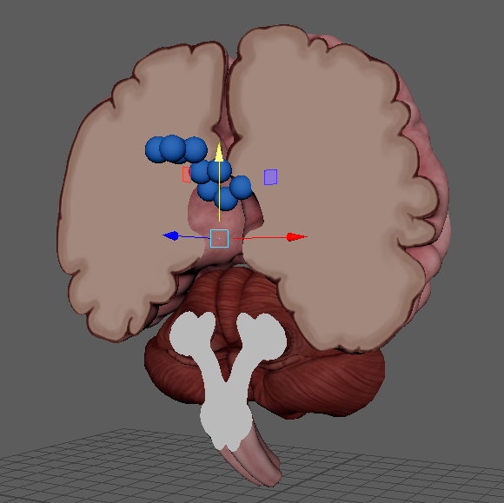
Missing internal structures, including termination of corpus callosum.
Left Occipital Cortex:
- The basic shapes obviously don’t work well for external surfaces like the cortex of the occipital lobe, perhaps a different approach is needed.
Thalamus:
- The cavernous interior of the brain, which should not be hollow, makes it possible that the user might try to click on the exposed upper surface of the thalamus. I have not placed any objects there, since it should not remain hollow.

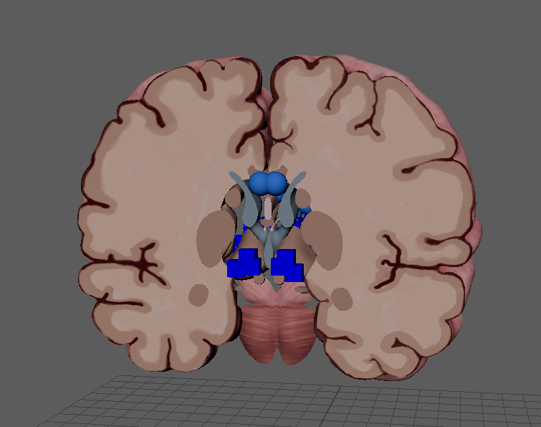
This surface should not be showing.

